June/July 2023

M418 Water Main Improvement Works

Settlers Run, Botanic Ridge – Night works date change.

In Melbourne, water is essential to our way of life. Today, clean, affordable water is readily available to our homes and businesses whenever we need it. Running from Beaconsfield to Langwarrin, the M418 water main is integral to the water supply for the Mornington Peninsula area.

## What are we doing?

To protect and enhance the M418 water main, we need to install 1 divide and 2 air valves across the water main in Settler Run, Botanic Ridge. Works will require machinery to dig an area to expose the main and install the new air and divide valves. Before the new divide valve can be installed, the water main needs to be drained. As the timing of these works are critical, the draining of the water main will require overnight works over three days. This will not impact water supply to the community.

**Location of Works**

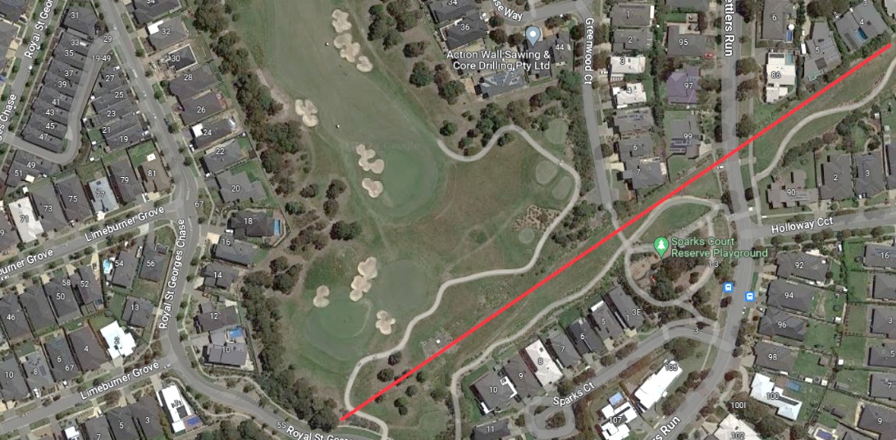**Settlers Run, Botanic Ridge** (Rear of Settlers Run, Golf Course) - Work Area

**What to expect?**

While the project team will make every effort to minimise disruption and inconvenience to you during these essential works, you can expect some minor disruptions including:

* Site establishment in the vicinity of Greenwood Court and Settlers Run. The site will be secured with temporary fencing.
* Mid to large-sized machinery will be used onsite for shrub removal and digging.
* Cranes to assemble equipment
* Traffic management in place to safely guide pedestrians and road users if roads or paths are blocked.
* Increased truck movements for the delivery of equipment and heavy machinery.
* As the draining of the water main will require overnight works, light towers will be used.
* Moderate noise from generators, pumps, lights and welding could be experienced
* Noise mitigation strategies will be in place.

# Shrub Removal

Shrub removal will be minimal across the Melbourne Water sites. We understand this area is native to the Southern Brown Bandicoot, our works are low risk and will not have an impact.

**Working hours**

Works for the divide valve are scheduled to start in mid-June and will run for approximately 3 months. Works will take place between 7am and 6pm Monday to Friday, 7am and 1pm Saturday (if applicable). Night works are required to drain the water main, and install the divide valve. These works are proposed from 8 August non-stop to 10 August.

**What’s Next?**

Aqua Metro Services (AMS) will begin site establishment in mid-June.

We thank you for your patience and understanding while we undertake these important works.

Please note core services of water and sewerage will not be impacted by these works. If you notice a change in your service, please contact South East Water on 13 16 94.

|  |  |
| --- | --- |
| **Keep up to date with what’s happening**  For more information about this project please call Melbourne Water on 1800 955 166 or email M418Improvement.Project@melbournewater.com.au  For an interpreter, please call the Translating and Interpreting Service (TIS National) on 13 14 50 | **Visit us**  www.melbournewater.com.au  **Like us**  facebook.com/melbournewater  **Follow us**  @MelbourneWater |